DS LAB OUTPUTS
- Implement basic array operations: insertion, deletion, searching, and traversal
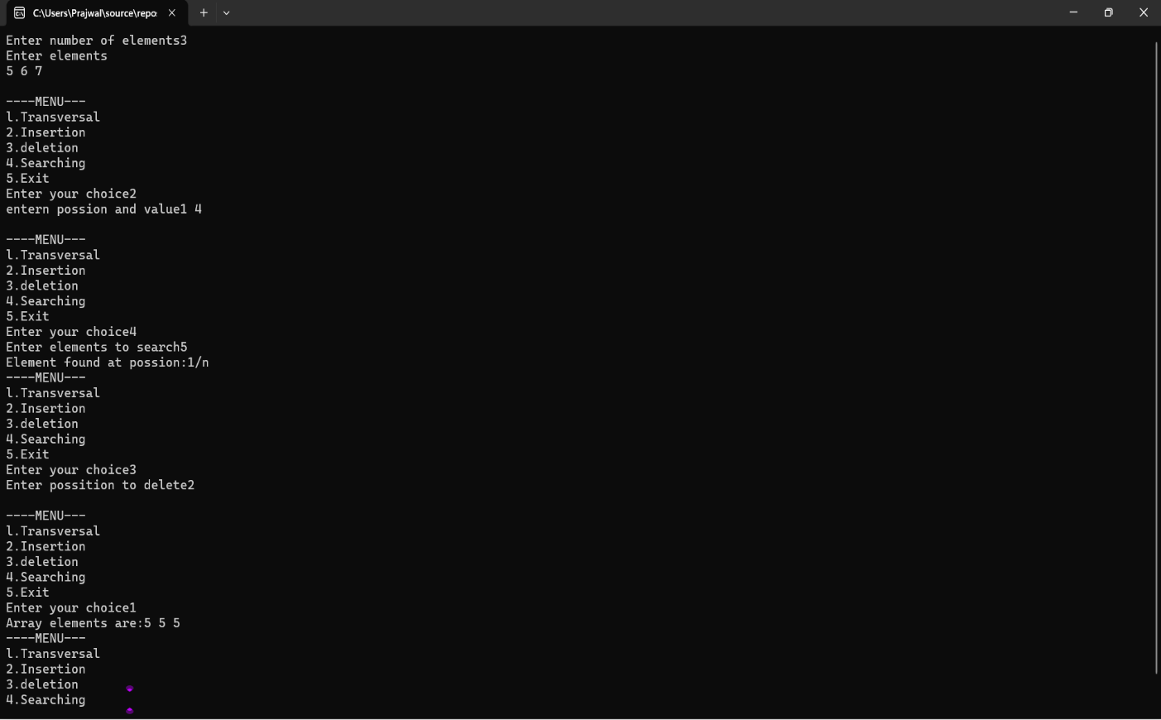

- Represent a sparse matrix using triplet form and perform transpose operation.
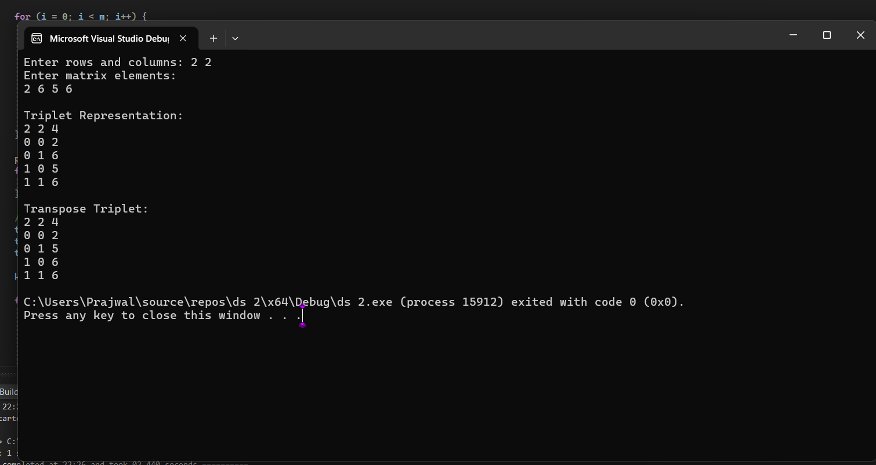

3 - 1. Implement stack operations using arrays
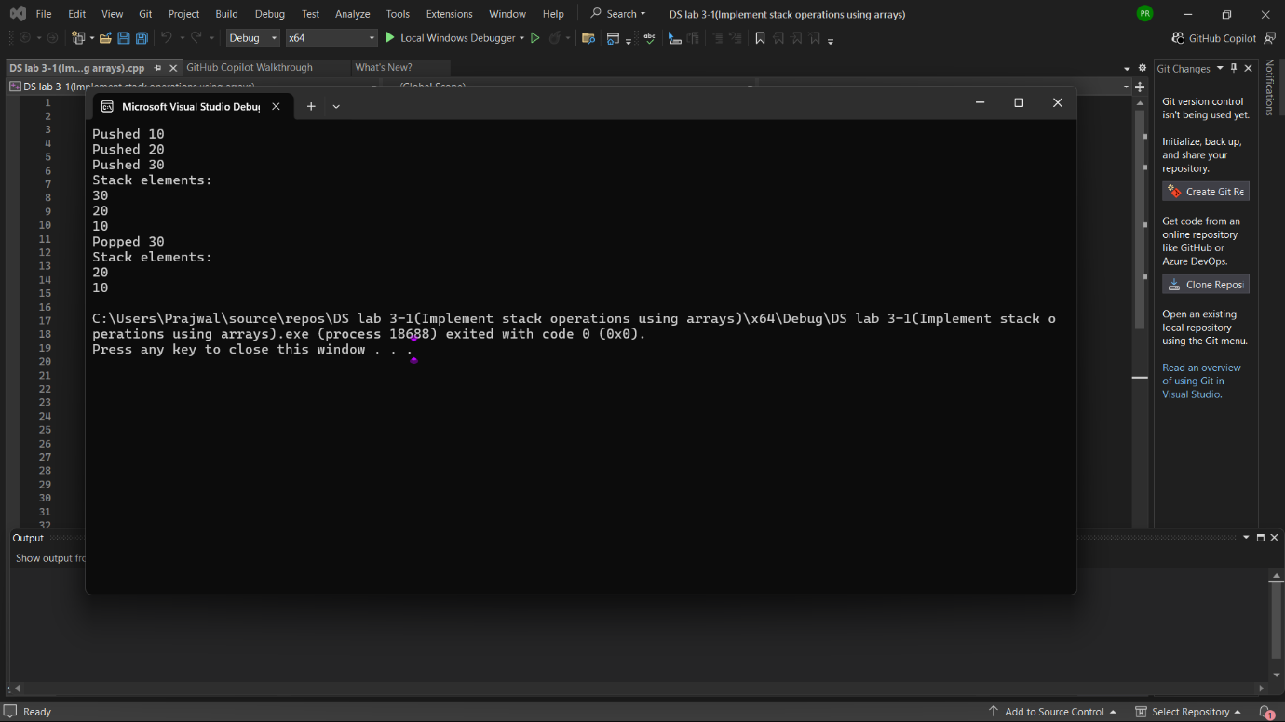

3 - 2. Implement stack operations using linked lists.
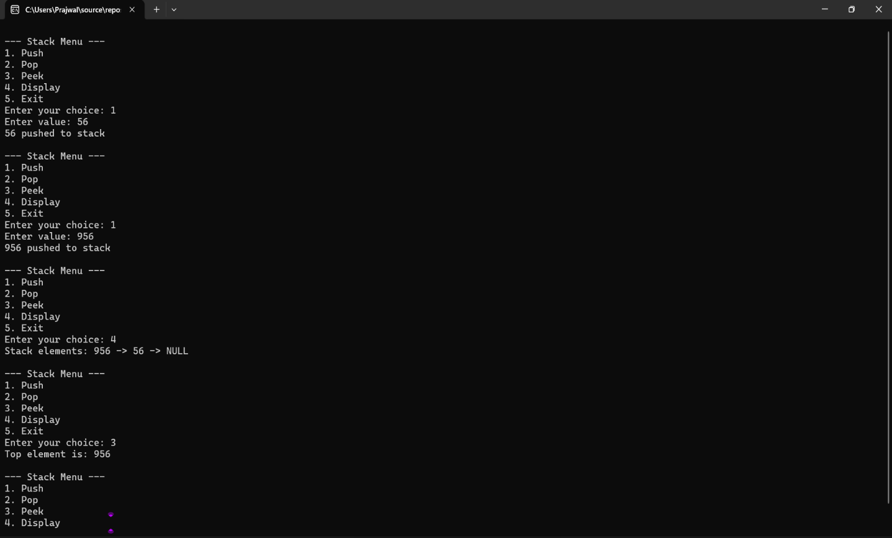

4.Convert an infix expression to postfix using a stack.
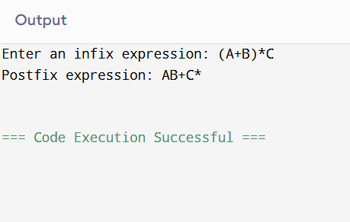

5. Evaluate a postfix expression using a stack.
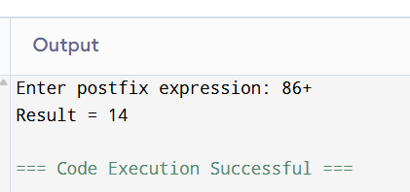

6 – 1. Implement queue operations using arrays
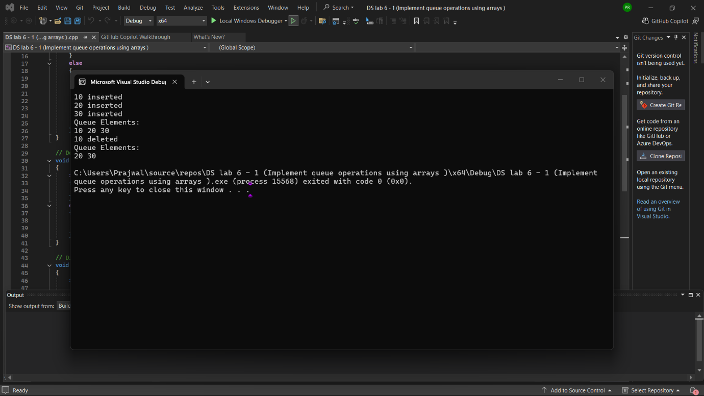
6 – 2. Implement queue operations using linked lists
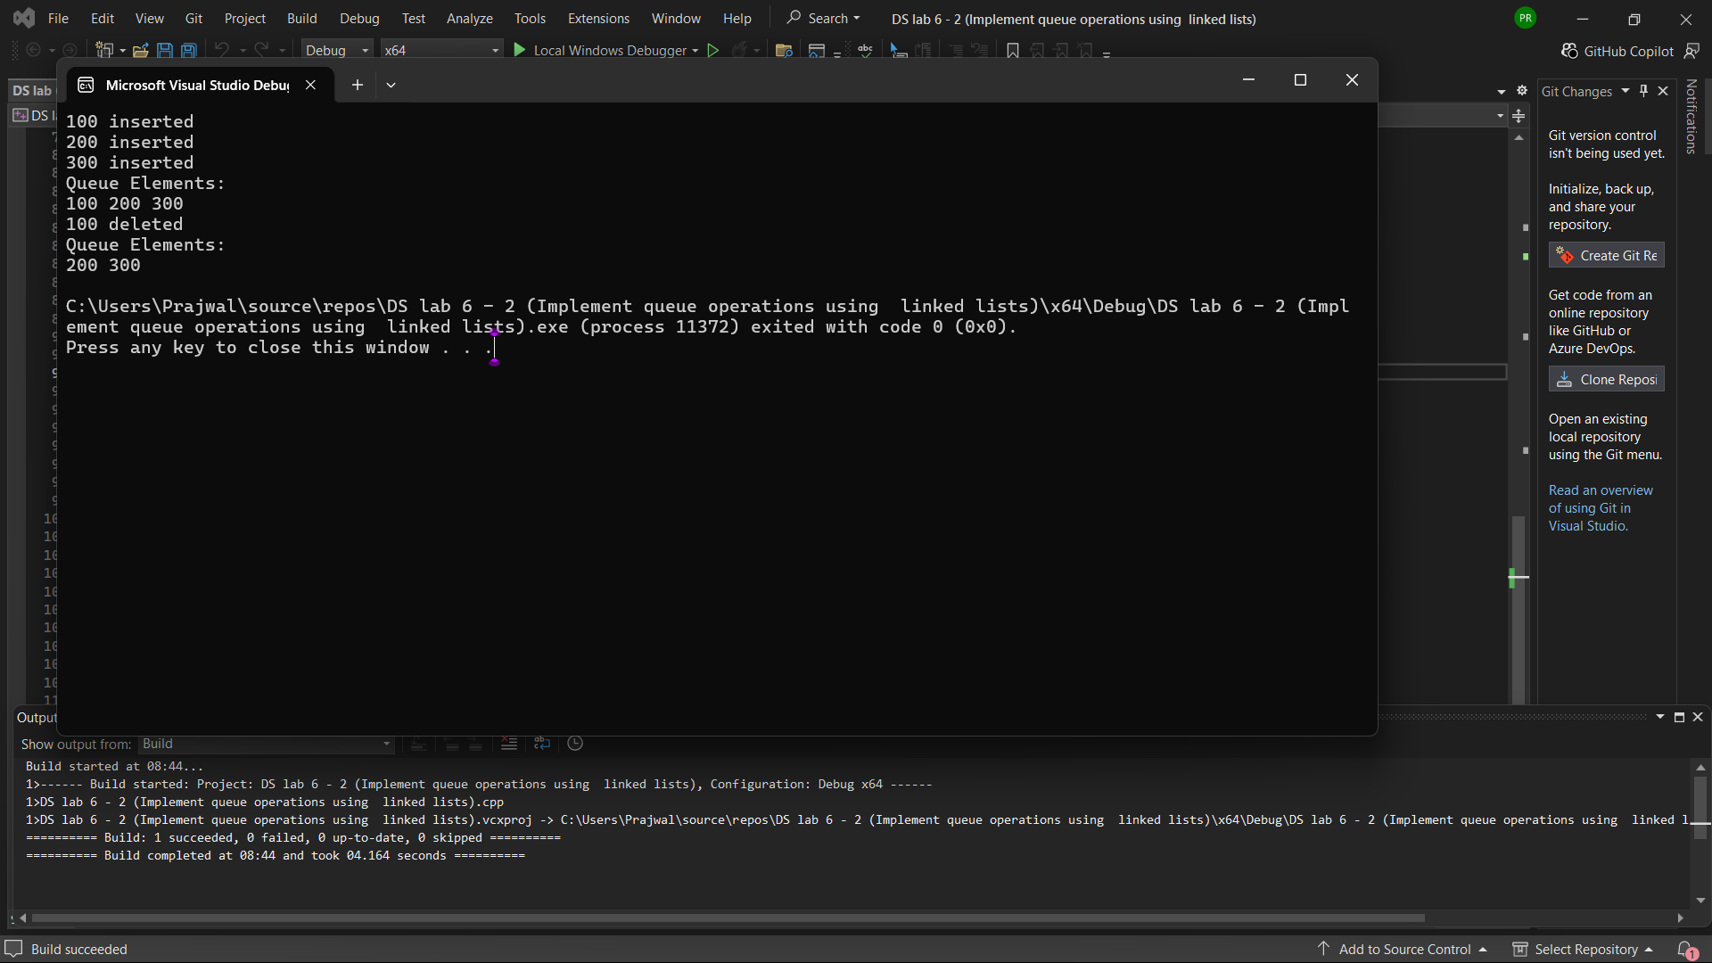

Program – 9=> Implement singly linked list operations: insertion, deletion, and search.
